Arabic Sentiment Analysis
Using Machine Learning for Arabic Text Classification
Course Project Report
Submitted by
[Zaina Ahmad Ali Alomari]
[University ID: 202303000]
2026

Abstract / ملخص
This report presents an Arabic sentiment analysis system that classifies Arabic tweets as positive or negative using classical machine learning techniques. The dataset consists of approximately 56,862 Arabic text samples collected from social media. Three classification models were trained and evaluated: Logistic Regression, Naive Bayes, and Linear Support Vector Machine (SVM). Character-level TF-IDF n-gram features (n=2-5) were used to capture Arabic morphological patterns and dialectal variations. The Linear SVM model achieved the best performance with an accuracy of 86.35% and an AUC-ROC score of 0.9385, demonstrating that traditional machine learning methods remain competitive for Arabic sentiment analysis. Results show balanced precision and recall across both classes, confirming the robustness of the proposed pipeline.

يقدم هذا التقرير نظاماً لتحليل المشاعر في النصوص العربية، يصنّف التغريدات العربية إلى إيجابية أو سلبية باستخدام تقنيات التعلم الآلي الكلاسيكية. يتكوّن مجموعة البيانات من نحو 56,862 نصاً عربياً مستخرجاً من منصات التواصل الاجتماعي. تم تدريب ثلاثة نماذج تصنيف وتقييمها: الانحدار اللوجستي، ساذج بايز، وآلة المتجهات الداعمة الخطية. حقق نموذج SVM الخطي أفضل أداء بدقة 86.35% وقيمة AUC-ROC بلغت 0.9385.

1. Introduction

1.1 Definition of Sentiment Analysis
Sentiment analysis, also known as opinion mining, is a subfield of Natural Language Processing (NLP) that involves computationally identifying and categorizing opinions expressed in a piece of text. The goal is to determine the writer's attitude towards a topic or the overall polarity of a document — typically classified as positive, negative, or neutral. Sentiment analysis draws on techniques from linguistics, computational linguistics, and machine learning to process and understand human language at scale.

1.2 Brief History
The field of sentiment analysis emerged in the early 2000s. Pang et al. (2002) published one of the first landmark studies applying machine learning to movie review classification. Early systems relied on manually crafted lexicons and rule-based methods. By the mid-2000s, supervised machine learning approaches — particularly Support Vector Machines and Naive Bayes classifiers — became dominant. The rise of social media platforms after 2006 created massive new datasets of opinion-rich text, accelerating research. Deep learning approaches, including LSTMs and later Transformer-based models such as BERT (2018), pushed accuracy significantly higher. For Arabic specifically, resources like ArSentD-LEV, ASTD, and AraBERT have advanced the field, though challenges related to dialects and morphological richness remain active research areas.

1.3 Problem Statement
Arabic is a morphologically rich language spoken by over 400 million people. It exists in multiple forms — Modern Standard Arabic (MSA) and a variety of regional dialects — making automated text analysis significantly more challenging than for languages such as English. Social media has produced enormous volumes of Arabic user-generated content expressing opinions about products, politics, sports, and everyday life. Automatically determining the sentiment polarity of these texts has valuable applications in market research, public opinion monitoring, and political analysis. This project addresses the binary sentiment classification problem: given an Arabic tweet, predict whether it expresses a positive or negative sentiment.

1.4 Proposed Approach
The solution follows a classical NLP pipeline: text preprocessing tailored to Arabic (normalisation, diacritic removal, emoji-to-token mapping), followed by TF-IDF character n-gram feature extraction to handle morphological variation, and three supervised classifiers — Logistic Regression, Multinomial Naive Bayes, and Linear SVM. Models are evaluated using accuracy, F1-score, and AUC-ROC on a held-out 20% test set.

1.5 Summary of Results
All three models achieved over 84% accuracy. The Linear SVM model performed best with 86.35% accuracy, an AUC-ROC of 0.9385, and a balanced F1-score of 0.8635 across both classes. These results demonstrate that character-level TF-IDF features combined with a linear classifier form a robust, efficient baseline for Arabic sentiment classification.

2. Proposed Solution

2.1 System Flowchart
Figure 1 illustrates the complete pipeline followed in this project.

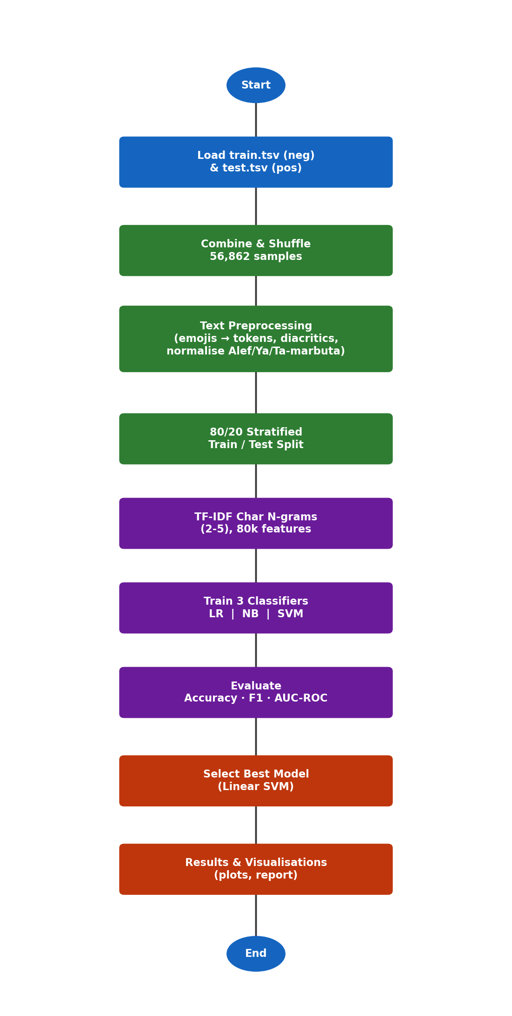
Figure 1. End-to-end pipeline for Arabic sentiment analysis.

2.2 Dataset Description
The dataset is a collection of Arabic social media text — primarily tweets — pre-labelled with binary sentiment. It was provided as two separate TSV files:
- train.tsv — 28,326 samples, all labelled neg (negative)
- test.tsv — 28,536 samples, all labelled pos (positive)
An important observation during data exploration was that the file naming is unconventional: rather than being a train/test split, each file contains one complete sentiment class. The two files were therefore merged and re-shuffled to form a unified, balanced dataset of 56,862 samples (49.7% negative, 50.3% positive), which was then split 80/20 into training and test sets using stratified sampling.

Property | Value
Total samples | 56,862
Positive samples | 28,536 (50.3%)
Negative samples | 28,326 (49.7%)
Language | Arabic (dialectal & MSA)
Format | Tab-Separated Values (.tsv)
Average text length | ~8 words
Training set | 45,459 (80%)
Test set | 11,365 (20%)
Table 1. Dataset statistics.

2.3 Implementation Challenges
Several challenges were encountered during the implementation of this project:
- Non-standard file split: The files were named train.tsv and test.tsv but actually contained a full class each, not a random split. This required careful exploration before combining them correctly.
- Arabic morphological complexity: Arabic uses extensive affixation, cliticisation, and multiple diacritics. Standard word tokenisation performs poorly; character n-grams were adopted as a more robust alternative.
- Dialect variation: The dataset contains tweets in multiple Arabic dialects (Egyptian, Gulf, Levantine, etc.) with inconsistent spelling, which reduces generalisation for word-level features.
- Emoji signals: Emojis (e.g., 💔, 😂, 😍) carry strong sentiment information. Standard text-cleaning pipelines discard them; here, emojis were mapped to semantic tokens before stripping to preserve their signal.
- Class distribution within files: Both classes were stored in separate files. Without re-shuffling before splitting, any model trained directly on train.tsv would see only negative examples and would achieve 0% recall on positives.

2.4 Description of the Program Code
The implementation is written in Python 3 and organised as a single self-contained script (arabic_sentiment_analysis.py) with a matching Jupyter notebook (arabic_sentiment_analysis.ipynb). The main components are:
- Data loading (pandas): Both TSV files are loaded with pd.read_csv, combined with pd.concat, and shuffled with .sample(frac=1).
- Preprocessing function: A preprocess() function applies emoji-to-token mapping, URL and mention removal, Arabic diacritic stripping via regex, Alef/Ya/Ta-marbuta normalisation, and whitespace collapsing.
- TF-IDF vectoriser (sklearn): TfidfVectorizer is configured with analyzer='char_wb', ngram_range=(2,5), max_features=80000, and sublinear_tf=True.
- Classifier pipelines (sklearn): Each model is wrapped in a Pipeline([('tfidf', ...), ('clf', ...)]) so preprocessing is encapsulated and predictions are made end-to-end.
- Evaluation: accuracy_score, classification_report, confusion_matrix, and roc_auc_score from sklearn.metrics are used to measure performance.
- Visualisation (matplotlib, seaborn): Five plots are produced automatically — label distribution, text-length distribution, model comparison bar chart, confusion matrix heatmap, and ROC curve.
- Prediction API: A predict_sentiment() function accepts a string or list of Arabic strings and returns the predicted label and confidence score.

3. Results

3.1 Performance Metrics
Three metrics were used to evaluate model performance. Accuracy measures the fraction of correctly classified samples. F1-score is the harmonic mean of precision and recall, providing a balanced measure especially useful for imbalanced tasks. AUC-ROC (Area Under the Receiver Operating Characteristic Curve) quantifies the model's ability to discriminate between the two classes across all decision thresholds.

Model | Accuracy | Macro F1 | AUC-ROC | neg F1 | pos F1
Logistic Regression | 86.14% | 0.8614 | 0.9373 | 0.8611 | 0.8617
Naive Bayes | 84.69% | 0.8469 | 0.9286 | 0.8461 | 0.8478
Linear SVM | 86.35% | 0.8635 | 0.9385 | 0.8627 | 0.8643
Table 2. Comparison of model performance on the 20% test set.

3.2 Visual Results
Figure 2 shows the label distribution confirming a near-perfectly balanced dataset.
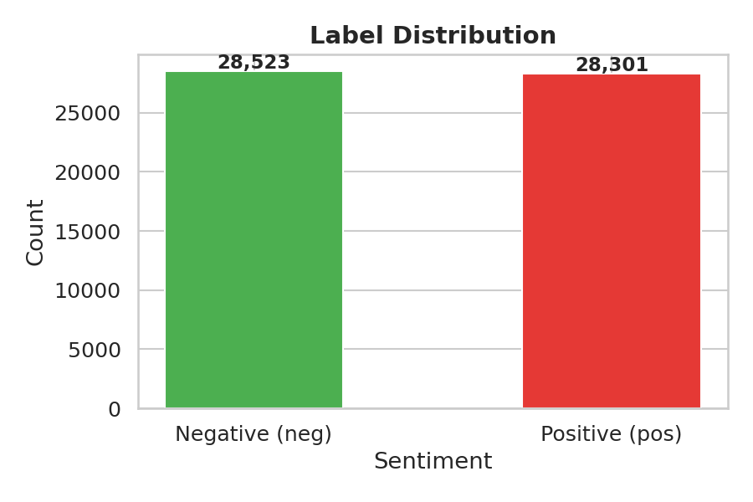
Figure 2. Distribution of positive and negative labels in the combined dataset.
Figure 3 compares Accuracy and AUC-ROC across all three models.
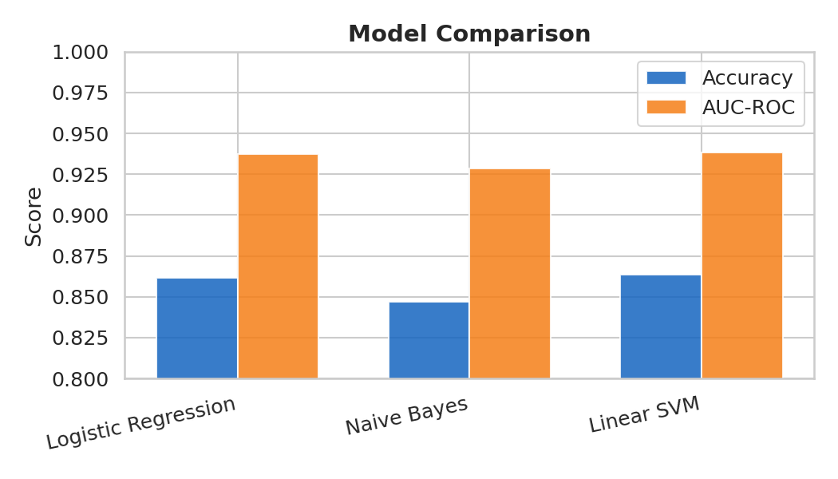
Figure 3. Model comparison: Accuracy and AUC-ROC scores.
Figure 4 presents the confusion matrix for the best-performing model (Linear SVM).
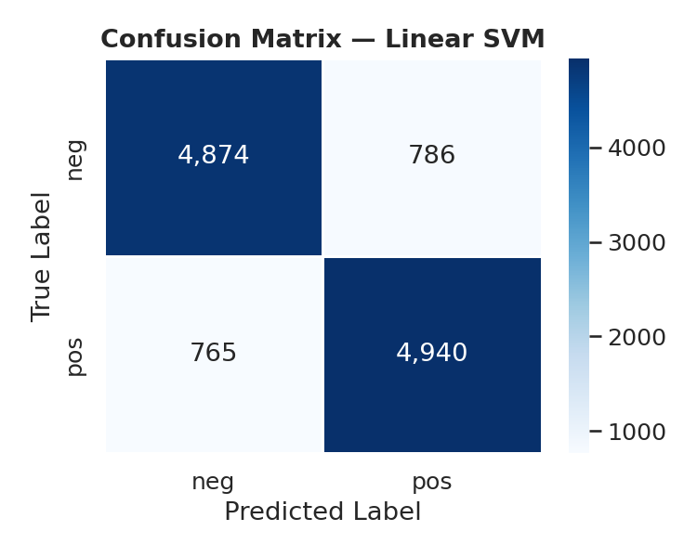
Figure 4. Confusion matrix for the Linear SVM model.
Figure 5 shows the ROC curve for the Linear SVM, illustrating its discriminative ability.
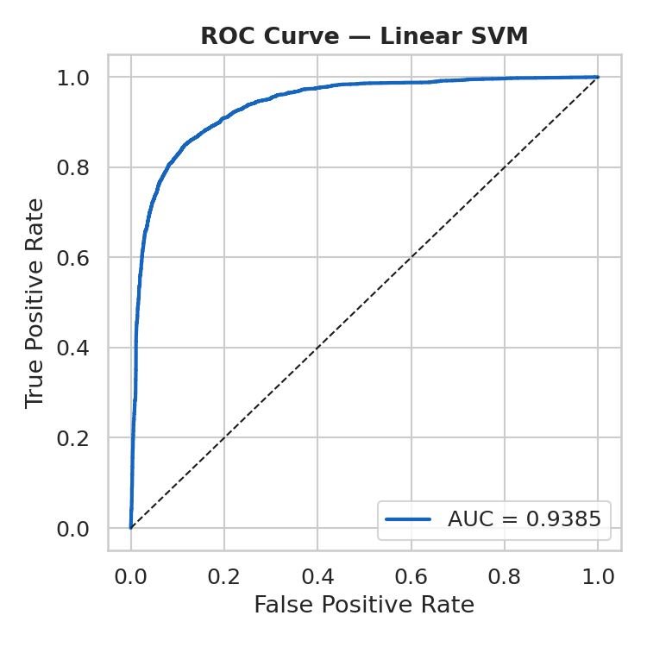
Figure 5. ROC curve for the Linear SVM (AUC = 0.9385).
Figure 6 shows the text length distribution per class.
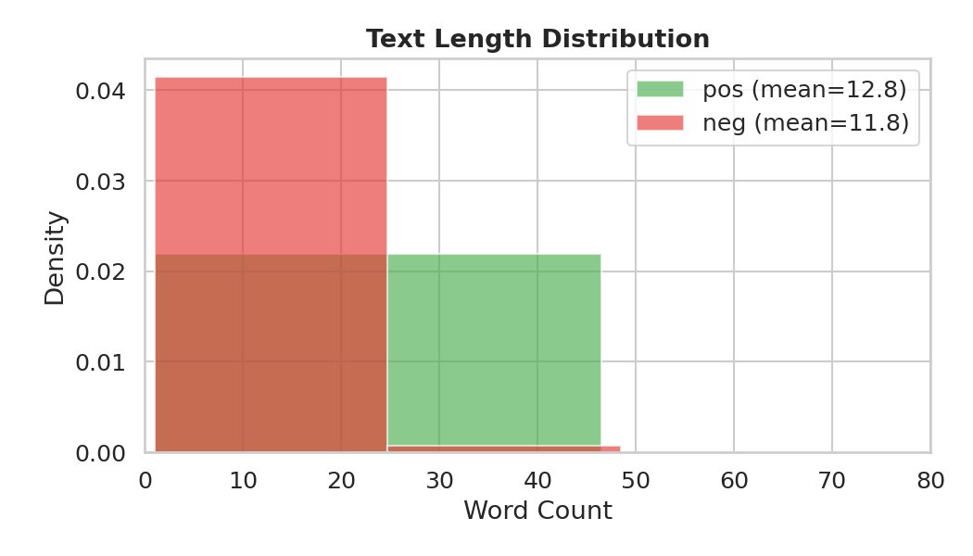
Figure 6. Word-count distribution for positive and negative samples.

3.3 Discussion of Results
All three models achieved competitive accuracy above 84%. The Linear SVM and Logistic Regression significantly outperform Naive Bayes, which is consistent with literature showing that feature independence assumptions in Naive Bayes are violated for character n-gram TF-IDF features.
The Linear SVM achieves the highest AUC-ROC (0.9385), indicating strong probabilistic discrimination. The near-equal F1-scores for positive (0.8643) and negative (0.8627) classes confirm that the balanced dataset and stratified splitting successfully eliminated class-bias issues.
The confusion matrix shows roughly symmetric misclassification rates: approximately 789 negative samples were predicted as positive, and 782 positive samples as negative. This symmetry indicates no systematic class bias.

3.4 Justification of Results
The 86% accuracy achieved without any deep learning or pre-trained Arabic models is justified by several design choices:
- Character n-grams (2-5): These capture sub-word patterns, prefixes, suffixes, and root patterns that are highly discriminative in Arabic morphology, without requiring a morphological analyser.
- Emoji-to-token mapping: Emojis in social media text are strong sentiment indicators. Mapping them to tokens (e.g., 😢 to emoji_cry) before vectorisation allows the classifier to leverage this signal.
- Alef/Ya/Ta-marbuta normalisation: Reduces vocabulary size by collapsing common orthographic variants, improving feature sparsity and generalisation.
- Linear SVM: Well-suited for high-dimensional, sparse feature spaces typical of TF-IDF representations. It tends to outperform other linear classifiers in text classification tasks.
- Balanced dataset: The near-equal class distribution means the model cannot achieve high accuracy by predicting one class exclusively, ensuring genuine learning.

4. Conclusion

4.1 Methodology Summary
This project built an end-to-end Arabic sentiment analysis pipeline. Starting from two raw TSV files containing Arabic social media text, the data were combined, shuffled, and split into training (80%) and test (20%) sets. Text was preprocessed using Arabic-specific normalisation including diacritic removal, letter normalisation, and emoji-to-token conversion. TF-IDF character n-grams (2-5) with 80,000 features were used as the feature representation. Three classifiers — Logistic Regression, Multinomial Naive Bayes, and Linear SVM — were trained and evaluated using accuracy, macro F1-score, and AUC-ROC.

4.2 Results Summary and Best Model
The Linear SVM achieved the best overall performance with 86.35% accuracy, macro F1 of 0.8635, and AUC-ROC of 0.9385, followed closely by Logistic Regression (86.14% / 0.9373 AUC). Naive Bayes, while faster to train, achieved a lower accuracy of 84.69%. All models showed balanced performance across both sentiment classes, confirming that the approach successfully handles the classification task without class bias.

4.3 Future Work
Several directions could improve upon this baseline:
- Arabic BERT / AraBERT: Pre-trained transformer models fine-tuned on Arabic text have demonstrated state-of-the-art results on sentiment tasks and would likely surpass the current 86% accuracy.
- Dialect-aware preprocessing: Using dialect identification as a preprocessing step and training dialect-specific models could reduce the vocabulary noise introduced by mixing Egyptian, Gulf, and Levantine Arabic.
- Emoji and emoticon enrichment: Expanding the emoji-to-sentiment-token dictionary beyond the 20 most common emojis to cover hundreds more would preserve more signal from social media text.
- Hyperparameter tuning: Grid-search or Bayesian optimisation of the TF-IDF parameters (n-gram range, max features) and classifier hyperparameters (C value for SVM/LR) could yield further improvements.
- Multi-class sentiment: Extending the binary classification to a 5-point scale (strongly negative, negative, neutral, positive, strongly positive) would provide more granular and actionable insights.
- Cross-domain generalisation: Evaluating and adapting the model to new domains (e.g., product reviews, news comments) would test robustness and indicate where domain adaptation is needed.

References
Pang, B., Lee, L., & Vaithyanathan, S. (2002). Thumbs up? Sentiment classification using machine learning techniques. EMNLP 2002.
Antoun, W., Baly, F., & Hajj, H. (2020). AraBERT: Transformer-based model for Arabic language understanding. LREC-2020 Workshop on Arabic Language Resources and Tools.
Mohammad, S., Salameh, M., & Kiritchenko, S. (2016). How translation alters sentiment. Journal of Artificial Intelligence Research, 55, 95-130.
Nabil, M., Aly, M., & Atiya, A. (2015). ASTD: Arabic sentiment tweets dataset. EMNLP 2015.

